IMPLEMENTING WEB APPLICATION

CREATE UI TO INTERACT WITH APPLICATION

|  |  |
| --- | --- |
| Date | October 30 2022 |
| Team ID | PNT2022TMID01390 |
| Project Name | Job/Skill Recommender Application |

CREATE ACCOUNT PAGE:

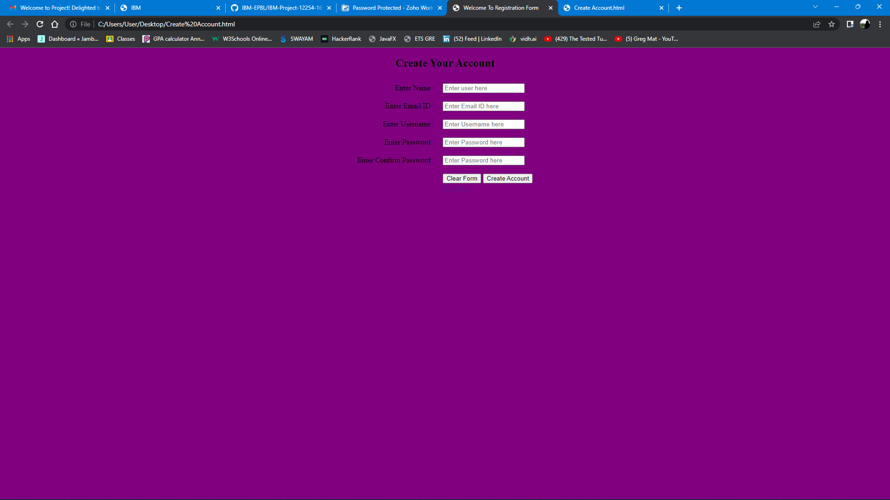

SOURCE CODE:

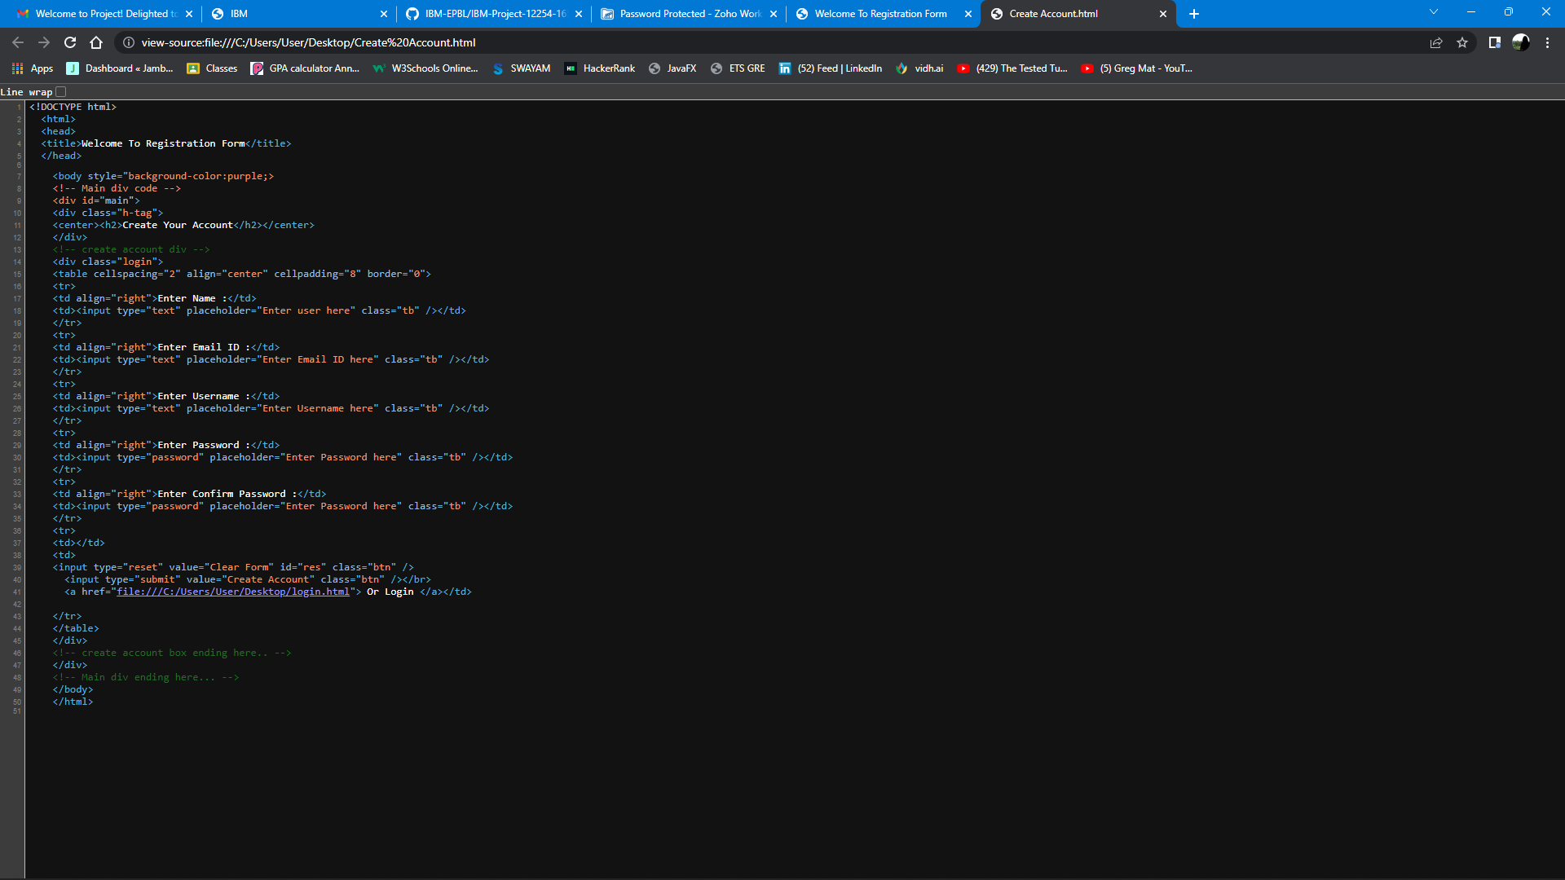

REGISTRATION PAGE:

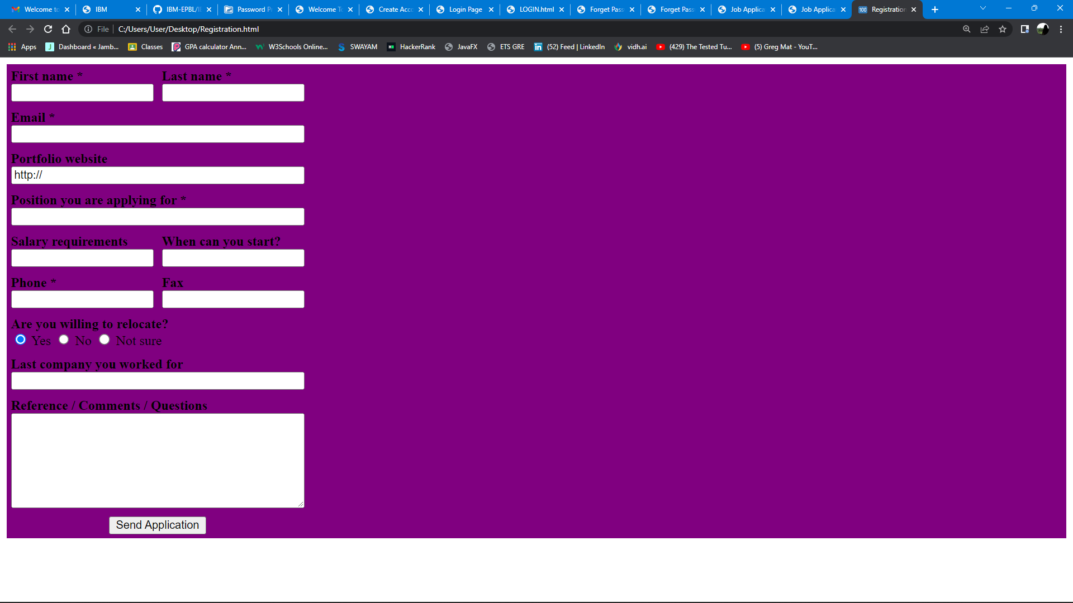

SOURCE CODE:

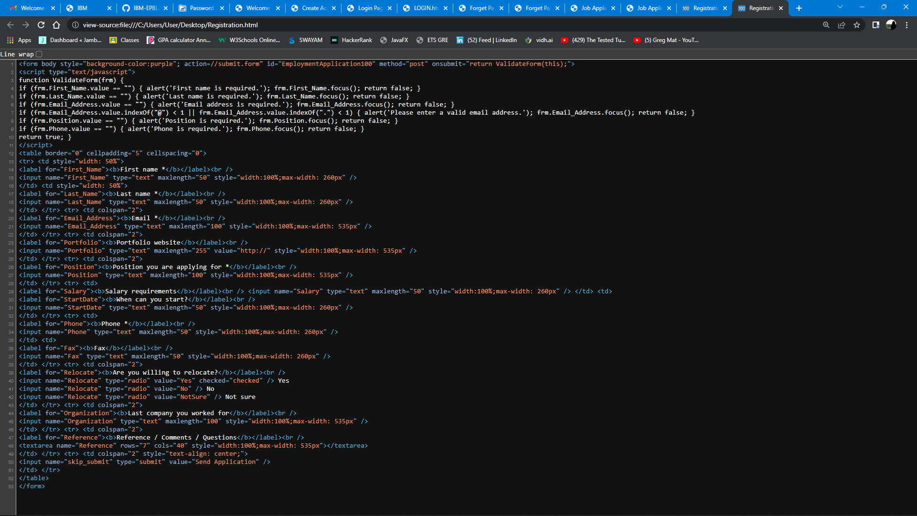

LOGIN PAGE:

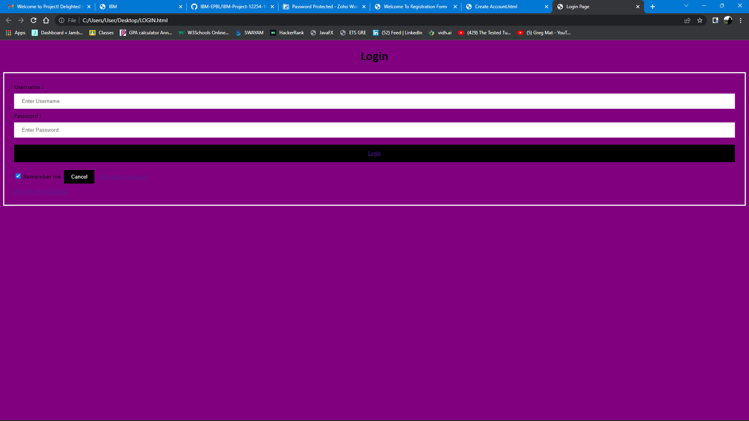

SOURCE CODE:

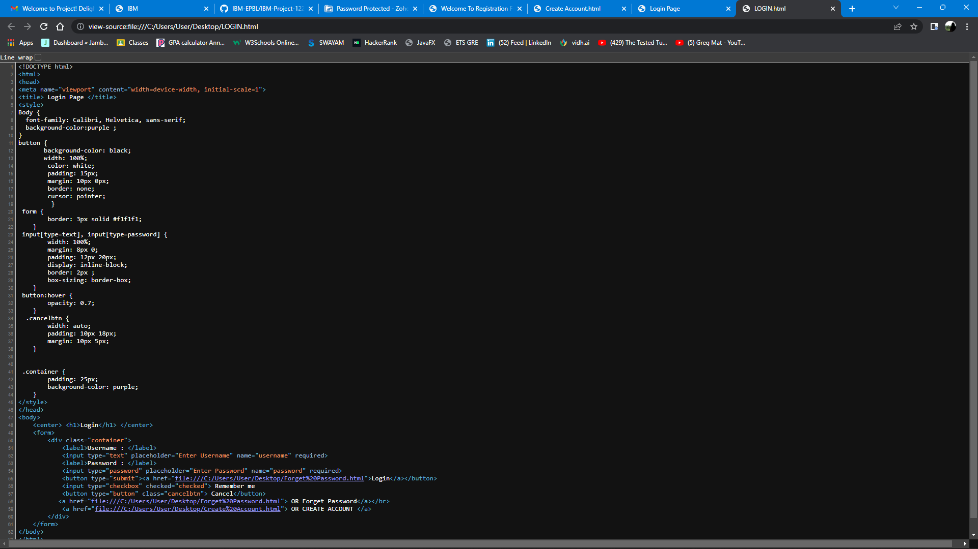

FORGET PASSWORD:

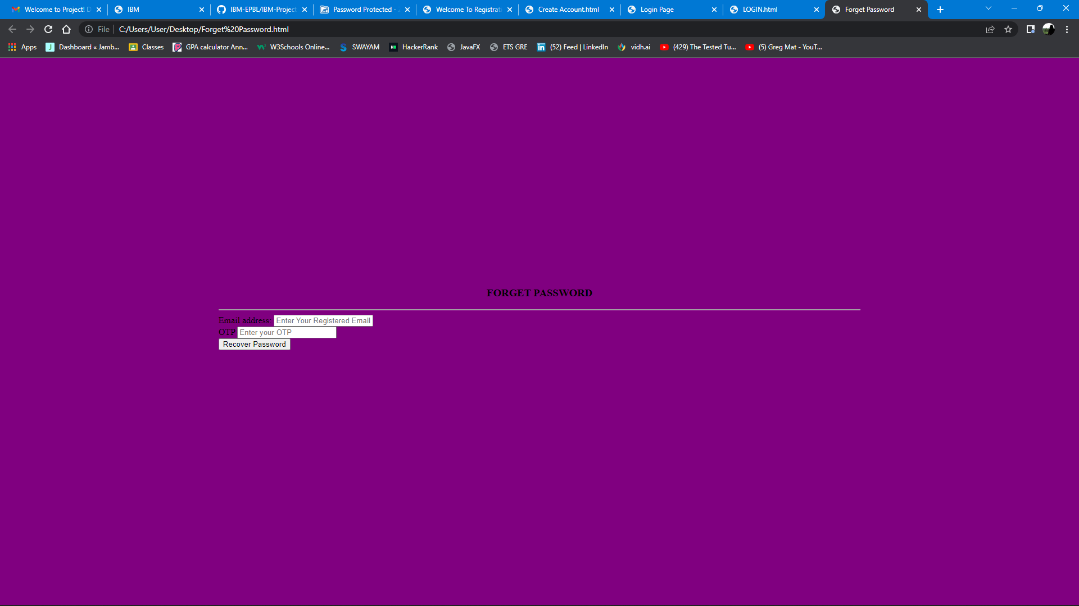

SOURCE CODE:

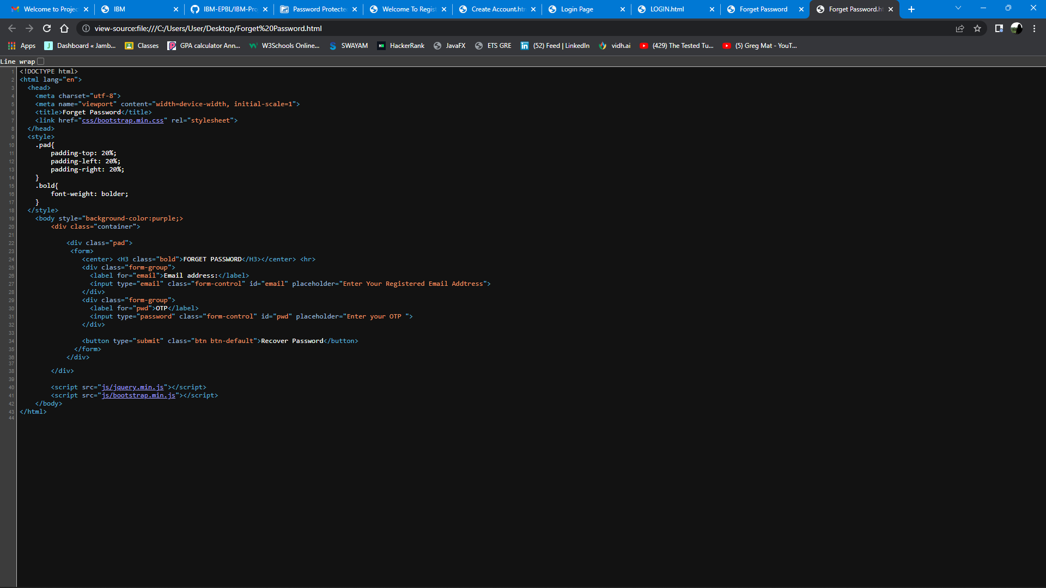

JOP APPLICATION PAGE: 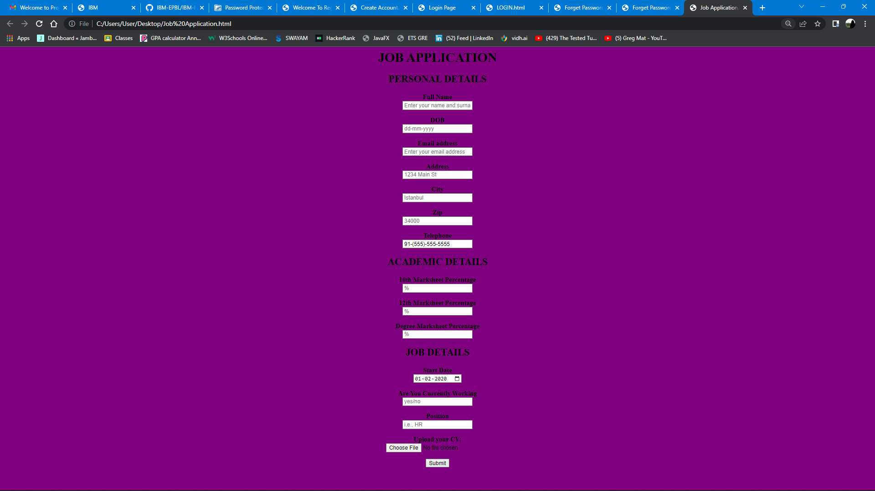

SOURCE CODE:

